 | Testing and Training Center of Farm Machinery  Department of Farm Machinery and Power Engineering  College of Agricultural Engineering and Technology  Junagadh Agricultural University  JUNAGADH – 362 001 (GUJARAT) | 
P | Phone : (0285) 2672080-90, Ext. 390 & 484; Fax : (0285) 2671018

SPECIFICATION SHEET OF TRACTOR MOUNTED HYDRAULIC REV. M. B. PLOUGH

1.0 | General | :
1.0 | Name of machine | :
1.0 | Name and address of manufacturer | :
1.0 | Name and address of applicant | :
1.0 | Selling price in India | :

2.1 | Frame:
2.1 | a) |  |  |  | Constructional details |  |  | :
2.1 | b) |  |  |  | Dimensions (mm):
2.1 | i |  |  |  | Length |  |  | :
2.1 | ii |  |  |  | Width -At front |  |  | :
2.1 |  |  |  |  | -At rear |  |  | :
2.1 | iii |  |  |  | Number & size of holes on frame for fixing standard (mm) |  |  | :
2.2 | Standard:
2.2 | a) |  |  | Numbers |  |  |  | :
2.2 | b) |  |  | Material |  |  |  | :
2.2 | c) |  |  | Type |  |  |  | :
2.2 | d) |  |  | Dimensions (mm)
2.2 |  |  |  | - Projected length |  |  |  | :
2.2 |  |  |  | - Curved length |  |  |  | :
2.2 |  |  |  | - Width |  |  |  | :
2.2 |  |  |  | - Thickness |  |  |  | :
2.2 | e) |  |  | No., size & spacing of holes for fixing frog (mm) |  |  |  | :
2.2 | f) |  |  | No. & size of holes for fixing to the frame |  |  |  | :
2.2 | g) |  |  | Method of fixing |  |  |  | :
2.3 | Plough Bottoms:
2.3 | a) |  |  | Numbers |  |  |  |  | :
2.3 | b) |  |  | Type |  |  |  |  | :
2.3 | c) |  |  | Size of plough (mm) |  |  |  |  | :
2.3 | d) |  |  | Vertical suction (mm) |  |  |  |  | :
2.3 | e) |  |  | Horizontal suction (mm) |  |  |  |  | :
2.3 | f) |  |  | Constructional details |  |  |  |  | :
2.3.1 |  | Mould Board:
 |  | a) |  |  | Numbers |  |  |  | :
 |  | b) |  |  | Type |  |  |  | :
 |  | c) |  |  | Material |  |  |  | :
 |  | d) |  |  | Dimensions (mm):
 |  |  |  |  | - Length |  |  |  | :
 |  |  |  |  | - Width |  |  |  | :
 |  |  |  |  | - Thickness |  |  |  | :
 |  | e) |  |  | No & size of hole on mould board (mm) |  |  |  | :
 |  | f) |  |  | Method of fixing mould board |  |  |  | :
2.3.2 |  | Share :
 |  | a) |  |  |  | Type |  |  | :
 |  | b) |  |  |  | Constructional details |  |  | :
 |  | c) |  |  |  | Dimensions (mm) |  |  | :
 |  | d) |  |  |  | Angle of inclination of share along the direction of travel (deg.) |  |  | :
 |  | e) |  |  |  | No & size of holes on share (mm) |  |  | :
 |  | f) |  |  |  | Method of fixing share to the bottom |  |  | :
2.3.3 |  | Share bar (Bar-point):
 |  | a) |  |  |  | Type |  |  | :
 |  | b) |  |  |  | Material |  |  | :
 |  | c) |  |  |  | Dimensions (mm) |  |  | :
2.3.4 |  | Shin of mould board:
 |  | a) |  |  |  | Numbers |  |  | :
 |  | b) |  |  |  | Material & thickness (mm) |  |  | :
 |  | c) |  |  |  | No & size of hole on shin for fixing on frog |  |  | :
2.3.5 |  | Landside:
 |  | a) |  |  |  | Numbers |  |  | :
 |  | b) |  |  |  | Material |  |  | :
 |  | c) |  |  |  | Dimensions (mm) |  |  | :
 |  |  |  |  |  | - Length & Thickness |  |  | :
 |  | d) |  |  |  | No & size of hole on landside (mm) |  |  | :
 |  | e) |  |  |  | Method of fixing landside to frog |  |  | :
2.3.6 |  | Braces:
 |  | a) |  |  |  | No. of braces |  |  | :
 |  | b) |  |  |  | Material & size (mm) |  |  | :
 |  | c) |  |  |  | Dimensions (mm)
 |  |  |  |  |  | - Projected length |  |  | :
 |  | d) |  |  |  | No. & size of hole on each brace (mm) |  |  | :
 |  | e) |  |  |  | Method of fixing |  |  | :
2.3.7 |  | Frog:
 |  | a) |  |  |  | Numbers |  |  | :
 |  | b) |  |  |  | Material |  |  | :
 |  | c) |  |  |  | Dimensions (mm) |  |  | :
 |  | d) |  |  |  | No. & size of holes on frog (mm) |  |  | :
 |  | i |  |  |  | -for mould board |  |  | :
 |  | ii |  |  |  | -for share |  |  | :
 |  | iii |  |  |  | -for standard |  |  | :
 |  | iv |  |  |  | -for landside |  |  | :
 |  | v |  |  |  | -for shin |  |  | :
2.4 |  | Reversing Mechanism:
 |  | a) |  |  |  | Type |  |  | :
 |  | b) |  |  |  | Mode of operation |  |  | :
2.4.1 |  | Main Shaft:
 |  | a) |  |  |  | Constructional details |  |  | :
2.4.2 |  |  | Cam:
 |  |  | a) |  |  |  | Material |  | :
 |  |  | b) |  |  |  | Dimensions (mm)
 |  |  | i |  |  |  | -Total Length |  | :
 |  |  | ii |  |  |  | -Effective length |  | :
 |  |  | iii |  |  |  | -Width |  | :
 |  |  | iv |  |  |  | -Thickness |  | :
 |  |  | v |  |  |  | -Size of cam pin (mm) |  | :
 |  |  | vi |  |  |  | -Size of linch pin hole on cam pin |  | :
2.4.3 |  |  | Hydraulic Cylinder:
 |  |  | a) |  |  |  | Type |  | :
 |  |  | b) |  |  |  | Size of cylinder (mm) |  | :
 |  |  | c) |  |  |  | Size of high pressure pipe line fitted on the cylinder (mm) |  | :
 |  |  | d) |  |  |  | Size of piston (mm) |  | :
 |  |  | e) |  |  |  | Size of connecting arm (mm) |  | :
 |  |  | f) |  |  |  | Stoke length (mm) |  | :
2.4.4 |  |  | Distributor: |  |  |  |  |  | :
 |  |  | a) |  |  | Type |  |  | :
 |  |  | b) |  |  | Overall Size (mm) |  |  | :
 |  |  | c) |  |  | No. and size of hose pipes between tractor and distributor (mm)
2.4.5 |  |  | Reversing Mechanism Lock |  |  |  |  |  | :
2.5 |  |  | Hitch Pyramid:
 |  |  | a) |  |  |  | Constructional details |  | :
 |  |  | b) |  |  |  | Size of upper hitch (mm) |  | :
 |  |  | c) |  |  |  | Size of Cross bar (mm) |  | :

Specification of Hitch Pyramid As per IS: 4468-1997 (Part-I)

Sr. | Dimension  (Refer Fig.1) | Description | Measurement
Upper Hitch attachments
1 | d₁ | Diameter of hitch pin hole
2 | b’₁ | Width between inner faces of yoke
3 | b’₂ | Width between outer faces of yoke
Lower hitch points
4 | D₂ | Dia. of hitch pin
5 | b’₃ | Linch pin hole distance
6 | l | Lower hitch point span
Other dimensions
 | Diameter of linch pin hole
7 | d | For upper hitch pin
8 |  | For lower hitch pin
9 | h | Mast height
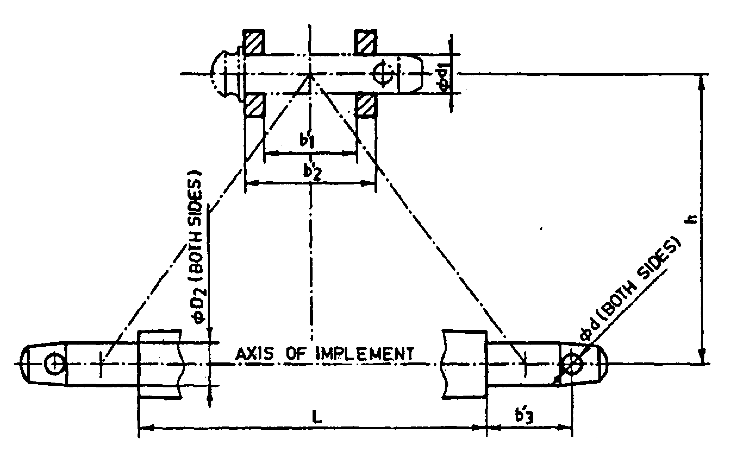
Implement Hitch Attachment
3.0 | Overall dimensions (mm) :
3.0 | a) | Length | :
3.0 | b) | Width | :
3.0 | c) | Height | :
4.0 | Total mass (kg) |  | :
5.0 | Color of implement |  | :

Place:
Date:
Signature : _________________________

Name : _________________________

Designation: ________________________

